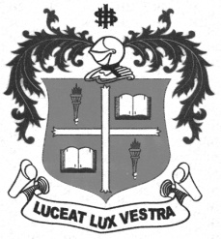
LOYOLA COLLEGE (AUTONOMOUS), CHENNAI – 600 034
B.A. DEGREE EXAMINATION – ENGLISH LITERATURE
FIFTH SEMESTER – NOVEMBER 2012

EL 5401 - INDIAN FOLKLORE

Date : 10/11/2012 Dept. No. Max. : 100 Marks
Time : 9:00 - 12:00

- Write short notes on any FIVE of the following in 50 words each: (5X4=20 marks)

- Folktales
- Epic
- Fables
- Wind instruments
- Structural theory
- Creation Myths
- Bharathnatyam
- Folk music

- Answer any FIVE of the following in 200 words each: ( 5x8=40 marks)

- Recall any folk tale that you have heard and analyze it with reference to the theory that you have learnt.
- Frame a dialogue with a prominent folk artist you know.
- What are the different kinds of folklore? Give examples.
- Write an account of musical instruments with a special emphasis on folk instruments.
- Explain the various theories pertaining to the origin of myths.
- India has seven classical dance forms. Of these, write an essay on any two.

- Attempt essays on any TWO in 350 words each: (2x20=40 marks)

- What is your opinion on the impact of westernisation on Indian folklore?
- Explain folk lore with respect to religion and analyse some religious myths and epics in this connection.
- Do you think the folklore of India will last forever? What are the ways by which folklore can be preserved?
*******

